1. INTRODUCTION:

PROJECT OVERVIEW

Fire and smoke kill more people every year than many other forces. While controlled fire serves us in so many instances, uncontrolled fire can be of harm, however, the rapid detection of fire and its control can save lives and property damage worth millions. Fire alarm systems are only effective if they can generate reliable and fast fire alerts with exact location of fire. There is a direct correlation between the amount of damage caused by fire and interventions time in various fire alarm systems. As the time of intervention decreases, the damage also decreases. Hence, the most important factor in a fire alarm system is the reaction or response time of fire alarm system (time between fire detection and extinguishing).

PURPOSE

An intelligent fire alarm system is specifically designed to provide advantages such as identification of the fire location, locate any fault in the alarm system wiring, and ensure easier maintenance. Moreover, these modern intelligent fire alarm systems are more sensitive as compared to the classic models and are competent to detect false alarms. Intelligent fire alarm systems utilize smart devices along with wireless technology to protect & manage buildings or workstations through a remote control panel (essentially a mobile application that can be downloaded, installed, and accessed from a smartphone). Intelligent fire alarm systems are usually available in three designs: addressable, conventional, and wireless.

1. LITERATURE SURVEY:

EXISTING PROBLEM

Here are some perks to adore before setting up an automated fire management system. The salient features are as follows.

* **Determine the status periodically**: The derived system should analyse the status of the fire accident at periodic intervals of time. This should work fine in real time as many industries are prone to accidents.
* **Transfer of information:** Manually transferring information over automatic mechanism is not feasible down the line.
* **Analysing the physical parameters**: Unable to obtain the physical parameters such as temperature and pressure in areas which are prone to fire accidents.
* **Cumbersome repair:** Tedious to determine structural damage**.**
* **Usage of technical skills for 3D spot:** MEMS are used for getting access of the building block.

REFERENCES

1. Liu Yunhong, Qi Meini, "The Design of Building Fire Monitoring System Based on ZigBee-WiFi Networks , Eighth International Conference on Measuring Technology and Mechatronics Automation, IEEE, 2016, pp-733-735
2. Ahmed Imteaj, Tanveer Rahman, Muhammad Kamrul Hossain, Mohammed Shamsul Alam, Saad Ahmad Rahat, "An IoT based fire alarming and authentication system for workhouse using Raspberry Pi 3". International Conference on Electrical, Computer and Communication Engineering (ECCE),

IEEE, 2017

1. Ondrej Krejcar, "Using of mobile device localization for several types of applications in intelligent crisis management",5th IEEE GCC Conference & Exhibition, IEEE, 2009
2. Karwan Muheden, Ebubekir Erdem, Sercan Vançin, "Design and implementation of the mobile fire alarm system using wireless sensor networks", 17th International Symposium on Computational Intelligence and Informatics (CINTI), IEEE, 2016
3. Azka Ihsan Nurrahman, Kusprasapta Mutijarsa, "Intelligent home management system prototype design and development", International Conference on Information Technology Systems and Innovation (ICITSI), IEEE, 2015.

PROBLEM STATEMENT DEFINITION

* The smart fire management system includes a gas sensor, flame sensor and temperature sensors to detect any changes in the environment.
* Based on the temperature readings, if there is any presence of gas, then the exhaust fans are powered on.
* If any flame is detected, the sprinklers will be switched on automatically.
* Emergency alerts are notified to the respective authorities and the fire station.

1. IDEATION AND PROPOSED SOLUTION:

EMPATHY MAP CANVAS

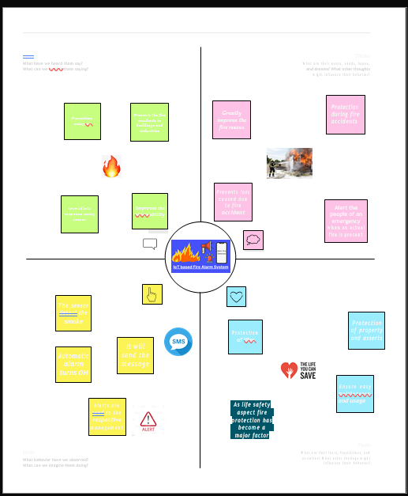

IDEATION AND BRAINSTORMING

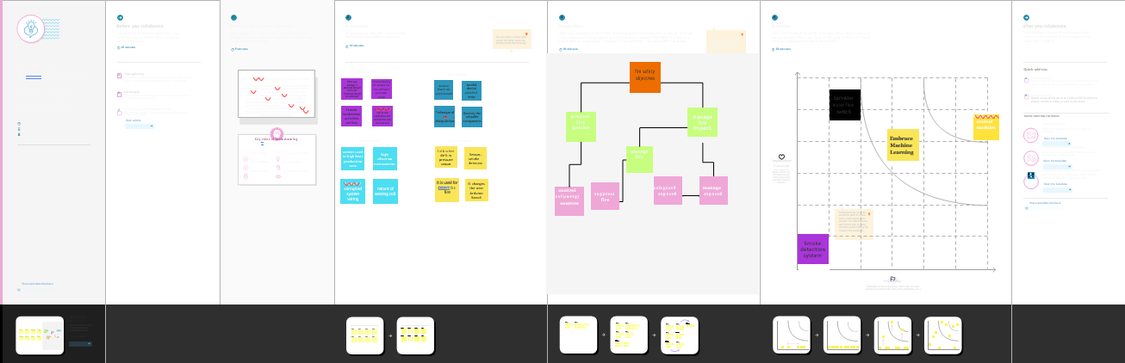

PROPOSED SOLUTION

The following are the parameters in finding a solution for the discussed problem.

* **Problem Statement (Problem to be solved)**- Enhancing the safety measures in industries that occur due to fire accidents and implementing the same.
* **Idea description-** Execution of fire management based on IOT consisting of Arduino uno board that comprises fire detection and fire extinguisher system, with the help of sensors like (Temperature sensor, Smoke sensor, Flame Sensor) which has Fast SMS

alert system.

* **Novelty / Uniqueness-** Making the best use of integrating certain tasks like temperature monitoring, gas monitoring, fire detection and automatic sprinklers so as to obtain accurate information about exact locations and to get response through SMS notifications and calls.
* **Social Impact / Customer Satisfaction-** Forecasting the mishap will notify the industry workers to migrate to better and safer buildings. Provides components with affordable prices and is highly feasible.
* **Business Model (Revenue Model)-** It is an industry-efficient product in all aspects. Provides a clear idea about the entire working mechanism of the system.
* **Scalability of the Solution-** Since, it deals with Arduino gadgets that must be capable of handling real-time signals from sensors. Helps in maintaining a large increase in

workload without undue strain.

PROBLEM SOLUTION FIT

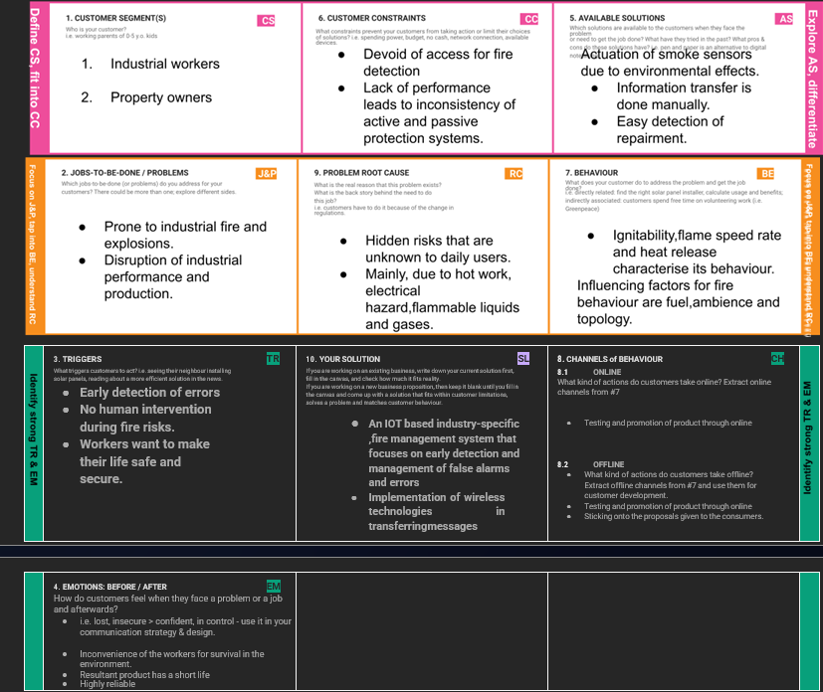

1. REQUIREMENT ANALYSIS:

FUNCTIONAL REQUIREMENT

Following are the functional requirements for the proposed solution.

* **User Requirements-** Industrial workers, automatic Water Sprinkler System that monitors Smoke, Gas and Temperature
* **User Registration-** Manual Registration

Registration through webpage

Registration through Form

Registration through Gmail

* **User Confirmation-** Confirmation via Phone number

Confirmation via Email id

Confirmation via (One time password) OTP

* **Payment Options-** Cash on Delivery

Net Banking (with standard gateways)

UPI mode of transaction

Credit card/Debit card/ATM card

* **Product Delivery and Installation-** Door Step delivery

Take away

Free installation and service for 1st year.

* **Product Feedback-** Via official Webpage

Via Phone calls

Through Google forms

NON FUNCTIONAL REQUIREMENTS

The following are the non-functional requirements.

* **Reliability-** Hardware configurations requires periodical service to avoid mishap. Software may be updated periodically. Immediate alert is provided in case of any system failure.
* **Performance-** Enhanced with proper user interface. Lesser energy consumption and long life of the battery. The product should work fine with real time applications as it has to deal with lives of people and products.
* **Availability-** According to the user requirement the features will be available at any time. Primarily, depends on the user requirement and the type of customization he wants.
* **Scalability-** The product has to adapt, accommodate and assemble to any portion of the industry ambience irrespective of space and size.
* **Usability-** Proper installation manual. Easier to use. Understandable by workers.
* **Security-** Periodically, inspected by the Fire Alarm technician and tagged by a contractor annually.

1. PROJECT DESIGN:

DATA FLOW DIAGRAM

SOLUTION AND TECHNICAL ARCHITECTURE

Architecture employed-

USER STORIES

* Being a user, one can register the application by entering email id, password and confirming the credentials.
* Connecting the sensors and arduino board with respective python code.
* Creation of specific devices in the IBM Watson IoT, and workflow using Node-Red.
* Using MIT app, creation of a mobile application for the fire management system.
* Being a user, I can get notification alerts.
* According to the emergency case, testing of the system is done at the place of deployment.
* Linking the app with IBM cloud.
* Deployment of IoT based Industry specific Intelligent fire management system which is accessible at any circumstances.

1. PROJECT PLANNING AND SCHEDULING:

SPRINT PLANNING AND ESTIMATION

|  |  |  |  |  |  |  |
| --- | --- | --- | --- | --- | --- | --- |
| **Sprint** | **Functional Requirement (Epic)** | **User Story Number** | **User Story / Task** | **Story Points** | **Priority** | **Team Members** |
| Sprint-1 | Registration | USN-1 | Being a user, one can register the application by entering email id, password and confirming the credentials. | 2 | High | Srimaithreyi S,Manasa padhy |
| Sprint-1 | Simulation | USN-2 | Connecting the sensors and arduino board with respective python code. | 1 | High | Srimaithreyi S, Bala sona |
| Sprint-2 | Software | USN-3 | Creation of specific devices in the IBM Watson IoT, and workflow using Node-Red. | 2 | Low | Lalith Kumar, Manasa Padhy |
| Sprint-1 | MIT App Inventor | USN-4 | Using MIT app, creation of a mobile application for the fire management system. | 2 | Medium | Bala Sona , Manasa Padhy |
| Sprint-1 | Login | USN-5 | Using the login credentials , I can login into the application. | 1 | High | Srimaithreyi S, Bala Sona |

|  |  |  |  |  |  |  |
| --- | --- | --- | --- | --- | --- | --- |
| **Sprint** | **Functional Requirement (Epic)** | **User Story Number** | **User Story / Task** | **Story Points** | **Priority** | **Team Members** |
| Sprint - 1 | Dashboard | USN-6 | Being a user, I can get notification alerts. | 1 | Medium | Lalith Kumar, Manasa Padhy |
| Sprint-3 | Testing and Development Phase 1 | USN-7 | According to the emergency case , testing of the system is done at the place of deployment. | 2 | High | Srimaithreyi S,Manasa Padhy |
| Sprint-3 | Linking | USN-8 | Linking the app with IBM cloud | 2 | High | Manasa Padhy, Lalith Kumar |
| Sprint-4 | Implementation | USN-9 | Deployment of IoT based Industry specific Intelligent fire management system which is accessible at any circumstances. | 2 | High | Bala Sona, Srimaithreyi S |

SPRINT DELIVERY SCHEDULE

* **Registration-** Any user has the ability to register the application through the gmail account.
* **Simulation-** The python code is connected with the Arduino board and sensors to check the process.
* **Software-** Some program oriented devices are created in the IBM watsoniot and workflow for better performance
* **MIT app inventor-** It is created for making a mobile application to prevent fire explosion.
* **Login-** It is used to get into an account for getting further details about the system.
* **Dashboards-** It helps getting notification alerts.
* **Testing and development phase 1-** At deployment phase, testing is done in order to check the working of the application.
* **Linking-** The app is now linked with IBM cloud.
* **Implementation-** This app is now put into action at various fire prone places**.**

REPORTS FROM JIRA

Creating roadmap-

Creating backlog-

PROCESSING OF SPRINT 1 ON BOARD-

COMPLETION OF SPRINT 1-

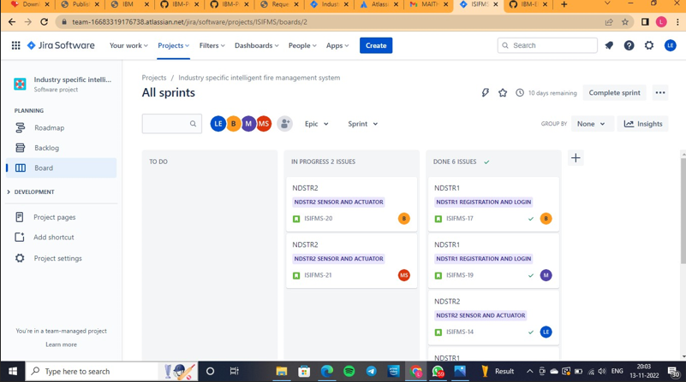

ROADMAP BY ALL SPRINTS-

ISSUES BY SPRINTS-

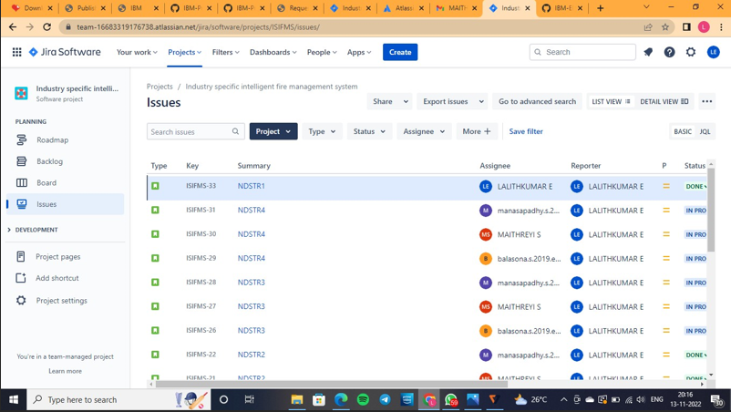

SPRINT 1 BURN UP REPORT-

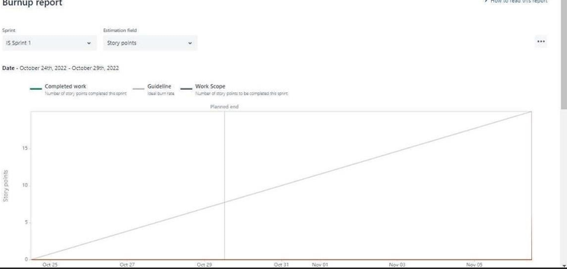

SPRINT 1 BURN DOWN REPORT-

SPRINT 1 VELOCITY REPORT-

1. CODING AND SOLUTIONING:

FEATURE 1

Fire alarm system is designed to alert us to an emergency so that we can take actions to protect ourselves, staffs and general public.

This project concentrates on the measures to prevent fire accidents caused due to flammable gas, smoke andrise in temperature. This system makes use of the best sensor available that detects any transpose in the environment. Basedon the sensor readings, if any disparity is encountered, appropriate actions will be taken in order to prevent any misfortune. This model incorporates MQ2 gas sensor for detecting propane and methane gases, IR Flame sensor module to detect flame and LM35 Temperature sensor for the temperature measurement of the environment. These readings are monitored continuously by IBM Watson IoT Platform and stored in Cloudant DB. In case any undesirable variation occurs, the authorities and fire stationwill be alerted via Fast2SMS web service. The smart fire management system includes a Gas sensor, Flame sensor and temperature sensors to detect any movement or change in the environment. If the presence of gas is felt, then the exhaust fans are powered ON. If any flame is detected, the sprinklers will be switched on automatically. Emergency alerts are notified to the authorities and Fire station.

FEATURE 2

This project not only uses special and advanced devices for its working, but also teaches strong leadership quality. Following are the examples.

* Understanding the project requirement- The Aim is team members are assigned with tasks for each to be executed as a responsible team lead. Also create repository in the Git hub-repo, Assign members and teach how to use and open the Git hub and IBM career education portals.
* Starting phase of project- Team lead to team members based on regularly attending training sessions for installing and use of prerequisite without skipping. Also necessarily attending the training sessions based on python code, development of android app in mobile app invtr.com and working along Node Red is ensured by the team lead and acknowledged by team members simultaneously.
* Attend class- Team members and team lead must watch and learn from classes provided byIBM and NALAYATHIRANand must gain access of MIT license for their project. IBM cloud service cloud Watson and node red service.
* Budget and scope of project- Budgetary planning process taken up on whole as a team to detect the user compatible price to the buy the product based on budgetary on IOT and component level.

Create a code snippet using python to

1. Extract weather data from OpenWeatherMap using APIs
2. Send the extracted data to the cloud
3. Receive data from the cloud and view it in the python compiler

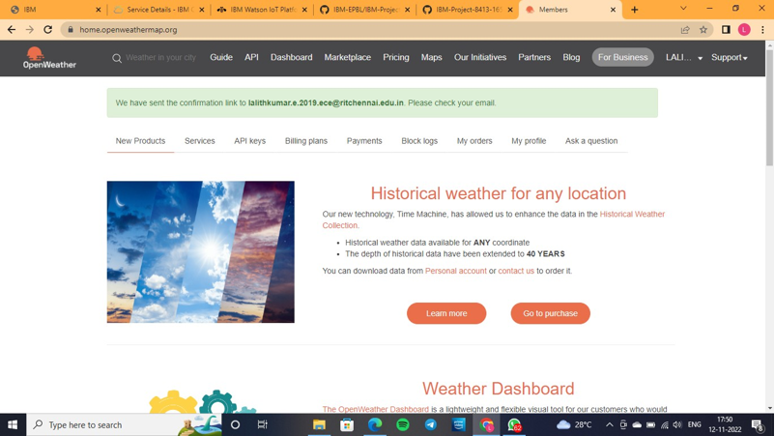

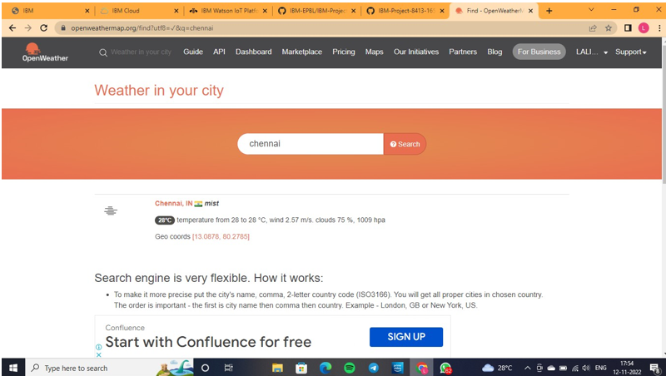

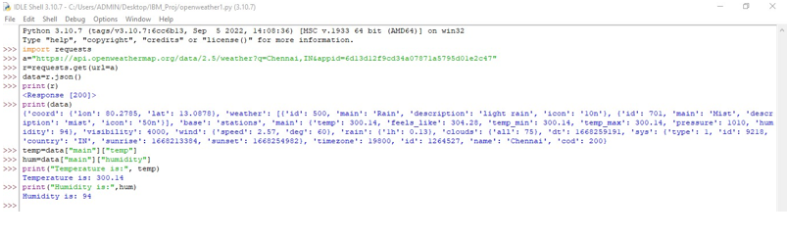

1. TESTING:

TEST CASES

The manufacturer's instructions has to be checked for the proper method of testing a fire alarm. But, in general, the USFA states most battery-powered and hardwired alarms can be tested in the following way:

**Step 1.** Alert family members that you will be testing the alarm. Smoke detectors have a high-pitched alarm that may frighten small children, so you'll want to let everyone know you plan to test the alarms to help avoid scaring anyone.

**Step 2.** Station a family member at the furthest point away from the alarm in your home. This can be critical to help make sure the alarm can be heard everywhere in your home. You may want to install extra detectors in areas where the alarm's sound is low, muffled or weak.

**Step 3.** Press and hold the test button on the smoke detector. It can take a few seconds to begin, but a loud, ear-piercing siren should emanate from the smoke detector while the button is pressed. If the sound is weak or nonexistent, replace your batteries. If it has been more than six months since you last replaced the batteries (whether your detector is battery-powered or hardwired), change them now regardless of the test result, and test the new batteries one final time to help ensure proper functioning. You should also look at your smoke detector to make sure there's no dust or other substance blocking its grates, which may prevent it from working even if the batteries are new.

Remember, smoke detectors have a normal life span of 10 years, according to the USFA. Even if you've performed regular maintenance, and your device is still functional, you should replace a smoke detector after the 10-year period or earlier, depending on the manufacturer's instructions.

Installing smoke detectors can be a great way to help keep your family safe, but assuming they are working may lead to a dangerous situation. Taking a few minutes to check them regularly can help ensure they're working properly.

USER ACCEPTANCE TESTING

**User Acceptance Testing (UAT)** is a type of testing performed by the end user or the client to verify/accept the software system before moving the software application to the production environment. UAT is done in the final phase of testing after functional, integration and system testing is done.

The main **Purpose of UAT** is to validate end to end business flow. It does not focus on cosmetic errors, spelling mistakes or system testing. User Acceptance Testing is carried out in a separate testing environment with production-like data setup. It is kind of black box testing where two or more end-users will be involved.

**Need of User Acceptance Testing** arises once software has undergone Unit, Integration and System testing because developers might have built software based on requirements document by their own understanding and further required changes during development may not be effectively communicated to them, so for testing whether the final product is accepted by client/end-user, user acceptance testing is needed.

Following are the entry criteria for User Acceptance Testing:

* Business Requirements must be available.
* Application Code should be fully developed
* Unit Testing, Integration Testing & System Testing should be completed
* No Showstoppers, High, Medium defects in System Integration Test Phase –
* Only Cosmetic error is acceptable before UAT
* Regression Testing should be completed with no major defects
* All the reported defects should be fixed and tested before UAT
* Traceability matrix for all testing should be completed
* UAT Environment must be ready
* Sign off mail or communication from System Testing Team that the system is ready for UAT execution

UAT Tester should possess good knowledge of the business. He should be independent and think as an **unknown user to the system**. Tester should be Analytical and Lateral thinker and combine all sort of data to make the UAT successful.Tester or Business Analyst or Subject Matter Experts who understand the business requirements or flows can prepare test and data which are realistic to the business.

1. RESULTS:

PERFORMANCE METRICS

Performance standards are an excellent tool in terms of fire safety because it encourages the adoption of recognised practices. These standards not only ensure that the risk of fires in the workplace is mitigated, but they also give staff peace of mind that their workplace is safe and fully compliant with the law.  
  
Being able to effectively measure how successful fire safety measures are is essential for effective fire safety management. If you are unable to measure the effectiveness of your fire safety, the framework in place is essentially moot because you don’t know how useful it will be in the event of an actual fire.

There are a number of factors to consider when developing a fire safety performance measuring system. Firstly, consider the frequency that you will be applying these measurements. If you have an older system in place, for example, you might want to increase the frequency to catch any issues as they develop.  
  
It’s also important to consider the full picture when looking at performance measurements, as a sole indicator might offer misleading results. There is a balance, however, as too many indicators muddy the water and make it difficult to gauge the overall performance of the system.  
  
A good way to approach fire safety performance measuring systems is to employ a balanced scorecard approach. This creates a good amount of data surrounding numerous fire safety activities that are tied to inputs, processes and outcomes. Factors to monitor might include:  
  
• Customer complaints  
• Effectiveness of controls such as general fire precautions or signage  
• The response to an incident and competency of the workforce involved  
  
There are other metrics to consider, such as benchmarking your performance against other organisations. It is key, however, to apply some form of performance measurements to your fire safety procedures.

Don’t delay, make sure your workplace fire safety is up to standard today.

1. ADVANTAGES AND DISADVANTAGES:

ADVANTAGES

* Cost effective for larger applications.
* The location of a fire condition is detected and recorded at each individual device, identifying exactly where the fire is occurring. This will improve response time for emergency responders.
* Lower ongoing service cost, because when a device goes into trouble (i.e. needs cleaning, repair or replacement), the panel will tell you the exact location of the device needing service.
* Online capabilities: New intelligent panels have the capability to provide detailed online notification of alarm/trouble/supervisory events.
* As far as fire alarm installers go, a wireless system is ideal because they are much easier to install. A wireless system essentially involves mounting the devices to the appropriate locations around a building or room, setting up the actual system and syncing it to WiFi. Compare this to a wired system, which requires fire alarm installers to connect the system to power supplies and ensure cables are connected properly.
* Another great advantage of a wireless fire alarm system is it operates off of a battery. This frees up a wall outlet and you can feel safe knowing the system will still work in the event of a power outage. And adding a second or subsequent wireless device is easy if you add on to your home or office.
* Reduced alarm response time
* Intelligence – devices communicate with the control panel and each other
* Reliable Fire & Security provides regular inspection and maintenance service for all types of fire alarms.
* These devices differ from their conventional counterparts because each device constantly communicates with the control panel.  Within seconds, alarms, supervisory and trouble conditions are alerted to the control panel and a precise location of the event is displayed.  Conventional alarm systems only “communicate” when there is an event.

DISADVANTAGES

* Cost, not as competitively priced for smaller applications.
* Typically with an intelligent panel, your peripheral devices   tend to be more expensive than conventional devices.
* This panel is computer like and at times there maybe issues caused by the firmware (panel software).  However, this is not common and the advantages of intelligent panel far outweigh any of these firmware issues.
* Maintaining the integrity of fire alarm systems in any building while integrating them with the building’s automation systems (BAS) requires more than just communication standards. The technology of building automationand control systems has advanced at a much faster pace over the past many years. Today’s technology provides building owners and designers with a rich assortment of options and flexibility with intelligent distributed controllers that process complex set of building information at lightning speed to efficiently characterize state-of-the-art building automation and control systems.
* These advances have taken place across a variety of building services including the control s systems for heating, ventilating, and air conditioning (HVAC), lighting, access and fire alarm. However, in spite of these advances in BAS, due to non-availability of any standard interfacing protocol, fire alarm systems have been finding it difficult to get integrated with BAS. To overcome this difficulty, in 1987, BACnet communication protocol was developed by the American Society of Heating Refrigerating, and Air-Conditioning Engineers (ASHRAE).
* BACnet product offerings range from gateways that connect proprietary systems to complete product lines that use BACnet as the primary or sole means of communication. The adoption of BACnet1 as the standard communication protocol for integrating building control products has changed the industry and opened the door to new innovation in building control technology and true integration of previously isolated building systems.
* Though BACnet provides the necessary isolation to Fire Alarm System, it also limits the integration possibilities. An alternative approach is to develop the best design practices for constructing networks of integrated systems. By appropriate selection of network technology and appropriate use of routers and bridges to filter traffic, interference problems and concerns about guaranteed access to network bandwidth in an emergency can be effectively eliminated.  
  11. CONCLUSION:  
   The primary advantage of a home fire alarm

system is increased reliability and the ability to place

alarms and bells exactly where needed. However, the

reason most people have them is that they wanted a

burglar alarm system and the cost of adding fire

alarm features to a residential burglary system is

relatively small.

Another advantage is that they are the only

way to obtain remote monitoring services. This

becomes important in cases where family members

may not be capable of escaping from a fire without

assistance. For example, if you have an older or

physically impaired person in your home and a fire

started when no one was home to assist that person,

alarms alone might not be enough to assure their

safety.

Fire wireless sensor platform of hardware

and software design for the entire system

development and application is essential, as the

bottom of the whole system support to the

miniaturization of its inevitable, highly integrated,

network-based, energy-saving and intelligent

direction, nearly few years, with the declining cost of

computer and microprocessor to reduce the size,

development and construction of intelligent wireless

fire alarm system will have broad application

prospects. Engineering test results fully demonstrated

the technical feasibility and the effectiveness of the

realization. (Ananthram, Qing, 2007).

Fire alarm systems that provide remote

monitoring services can also be used to provide

medical alert services. Here a person with health

problems who lives alone carries a radio transmitter

that can trigger the system in case they need

assistance. Signals received at the monitoring station

are identified by type (fire, burglary, medical alert) so

that the proper response can be made.

The primary advantage of a home fire alarm

system is increased reliability and the ability to place

alarms and bells exactly where needed. However, the

reason most people have them is that they wanted a

burglar alarm system and the cost of adding fire

alarm features to a residential burglary system is

relatively small.

Another advantage is that they are the only

way to obtain remote monitoring services. This

becomes important in cases where family members

may not be capable of escaping from a fire without

assistance. For example, if you have an older or

physically impaired person in your home and a fire

started when no one was home to assist that person,

alarms alone might not be enough to assure their

safety.

Fire wireless sensor platform of hardware

and software design for the entire system

development and application is essential, as the

bottom of the whole system support to the

miniaturization of its inevitable, highly integrated,

network-based, energy-saving and intelligent

direction, nearly few years, with the declining cost of

computer and microprocessor to reduce the size,

development and construction of intelligent wireless

fire alarm system will have broad application

prospects. Engineering test results fully demonstrated

the technical feasibility and the effectiveness of the

realization. (Ananthram, Qing, 2007).

Fire alarm systems that provide remote

monitoring services can also be used to provide

medical alert services. Here a person with health

problems who lives alone carries a radio transmitter

that can trigger the system in case they need

assistance. Signals received at the monitoring station

are identified by type (fire, burglary, medical alert) so

that the proper response can be made.

1. CONCLUSION:

The Industry specific intelligent fire management system can reduce the casualties of the disaster in industries to prevent the employees, industrial machines and infrastructure by providing appropriate evacuation guidance. The system can also aid disaster fighting with the help of water sprinklers because it allows for a quick assessment of the disaster with decentralized control that can intelligently guide evacuees based on the detection of humans.

The primary advantage of a home fire alarm

system is increased reliability and the ability to place

alarms and bells exactly where needed. However, the

reason most people have them is that they wanted a

burglar alarm system and the cost of adding fire

alarm features to a residential burglary system is

relatively small.

Another advantage is that they are the only

way to obtain remote monitoring services. This

becomes important in cases where family members

may not be capable of escaping from a fire without

assistance. For example, if you have an older or

physically impaired person in your home and a fire

started when no one was home to assist that person,

alarms alone might not be enough to assure their

safety.

Fire wireless sensor platform of hardware

and software design for the entire system

development and application is essential, as the

bottom of the whole system support to the

miniaturization of its inevitable, highly integrated,

network-based, energy-saving and intelligent

direction, nearly few years, with the declining cost of

computer and microprocessor to reduce the size,

development and construction of intelligent wireless

fire alarm system will have broad application

prospects. Engineering test results fully demonstrated

the technical feasibility and the effectiveness of the

realization. (Ananthram, Qing, 2007).

Fire alarm systems that provide remote

monitoring services can also be used to provide

medical alert services. Here a person with health

problems who lives alone carries a radio transmitter

that can trigger the system in case they need

assistance. Signals received at the monitoring station

are identified by type (fire, burglary, medical alert) so

that the proper response can be made

The primary advantage of a home fire alarm

system is increased reliability and the ability to place

alarms and bells exactly where needed. However, the

reason most people have them is that they wanted a

burglar alarm system and the cost of adding fire

alarm features to a residential burglary system is

relatively small.

Another advantage is that they are the only

way to obtain remote monitoring services. This

becomes important in cases where family members

may not be capable of escaping from a fire without

assistance. For example, if you have an older or

physically impaired person in your home and a fire

started when no one was home to assist that person,

alarms alone might not be enough to assure their

safety.

Fire wireless sensor platform of hardware

and software design for the entire system

development and application is essential, as the

bottom of the whole system support to the

miniaturization of its inevitable, highly integrated,

network-based, energy-saving and intelligent

direction, nearly few years, with the declining cost of

computer and microprocessor to reduce the size,

development and construction of intelligent wireless

fire alarm system will have broad application

prospects. Engineering test results fully demonstrated

the technical feasibility and the effectiveness of the

realization. (Ananthram, Qing, 2007).

Fire alarm systems that provide remote

monitoring services can also be used to provide

medical alert services. Here a person with health

problems who lives alone carries a radio transmitter

that can trigger the system in case they need

assistance. Signals received at the monitoring station

are identified by type (fire, burglary, medical alert) so

that the proper response can be madeFIRE ALARM SYSTEM

The intelligent fire management system makes full use of the fire information, realizes the information sharing of all parties, and improves the rescue ability of trapped persons and rescuers when the fire occurs. However, information collection, centralized processing and how to connect the information with the model to ensure the effectiveness of information and other factors, have a great impact on the overall practicality and reliability of the system, and is also the guarantee of maximizing the success of self-rescue and rescue. Therefore, strengthening the management of fire information will greatly improve the power of fire rescue, and it is of great significance to improve fire safety.

1. FUTURE SCOPE:

Until recently, fire and safety was something that was placed on the back-burner for many organizations. Most of the time was spent on mitigating risks after an accident had occurred rather than detecting or preventing them. In the past decade, however, there has been a huge shift towards how safety is viewed within enterprises. Many enterprises today are adopting a prevention-based approach and laying emphasis on identifying and addressing issues before someone gets hurt.

In fact, fire and safety preparedness of a company is now being related to its brand image. Further, business continuity and an always-on environment are a requirement for today’s businesses. As fire and safety incidents are major business disruptors, companies are taking proactive approach towards addressing safety issues. Being complaint to international standards is another reason that is driving this change in approach towards security.

More and more companies are focusing on employee training and education by organizing fire and safety workshops for employees, including contractual workers. Apart from fire and safety, organizations are also putting immense thrust on physical plant and facility security. They are actively evaluating advanced products and technologies to meet their safety criteria and objectives.

India’s economic growth, rapid industrialization, as well as growing commercial sector and real estate industry is further fuelling the demand for fire and safety equipment. According to the findings of TechSci Research, the country’s fire & safety equipment market has a strong growth potential and market revenues are expected to reach to about $4.94 billion by 2019.

To keep pace with the growing demand, the fire, safety and security industry is evolving rapidly and offering innovative products. Industrial Safety Review analyses the key trends and innovations emerging in the fire, safety and security segment and the future growth prospects.

Fire poses a significant risk in the workplace. Especially, when we consider work environments, such as construction sites, chemical laboratories and factories, the potential fire safety hazards are many. If we look at the statistics an average of 59 Indians are killed every day due to fire. In fact, fire accidents take away more lives than any natural calamity or disasters.

Given these alarming statistics, workplaces have increased their thrust on fire preparedness and are considering advanced fire detection and alarm systems. Fire equipment with ease of use features are also being demanded by organizations.

Advanced fire alarms today are equipped with individual smoke detector sensitivity adjustment and drift compensation. Fire alarms with maintenance-needed indication feature are also gaining popularity. Many products coming to the market today are equipped with multiple abilities. They just don’t detect smoke, but also have the ability to detect heat, carbon monoxide and infrared light from flames as well. These features help reduce the possibility of nuisance alarms as more than one criteria needs to be fulfilled to trigger an alarm and shorten the time required to detect the actual fire.

Wireless technology is transforming every industry and fire safety industry is no different. Wireless smoke detector systems are rapidly gaining popularity. Another technology that is seeing a surge in demand is voice annunciation as it allows danger to be announced with a pre-recorded message. Voice alert systems are set to become more popular as people have an increased reaction to voice instructions as compared to simple sirens.

With integrated building systems gaining momentum in residential and commercial complexes alike, the industry is looking at defining the rules as to how fire alarms and detection components will work when they are integrated with other building systems. For instance, if there is heavy traffic on the LAN, the system should be able to identify and give priority to fire alarm signals.

Also, the role of fire alarms and detection components is set to expand as they become integrated with other building systems. For instance, sensors used for controlling lighting in a room can be used in cases of fire to see if a room is occupied or not. Firefighters can then use this information to rescue in a speedy manner by eliminating unoccupied room.

Workplace safety is witnessing a huge shift with the wide-spread use of mobile phones and smart technology. As majority of workers carry their mobile phones to work today, organizations are focusing on utilizing mobile phones to oversee the safety of the employees.

Another interesting trend to watch out in the safety space is smart technology making its way into PPE. For years, PPE has consisted of overalls, gloves, masks, harnesses, etc., on which workers rely to ensure safety. Smart technology integrated into PPE has the potential to take workplace safety to another level. Utilizing in-built sensors, PPE equipment can monitor an employee’s vital data, including blood pressure, heart rate, blood oxygen levels and so on. This data can then be used to determine an employee’s alertness and can prove instrumental in preventing workplace accidents.

Big data analytics is a major trend that is streamlining every industry and safety industry is no different. Compiling and analysing safety, accident and incident reports and information about machines and equipment involved can help companies identify red flag issues. Analyzing this historical data gives companies a fair idea about where danger lurks in an organization and take steps to prevent future incidents.

Technology revolution is also impacting the traditional signage. Today, there is digital ‘smart’ signage that can change with changing conditions, and provide more eye-catching alerts for employees.

In the future, augmented reality will also be used to enhance workplace safety. For instance, wearable goggles may be embedded with AR technology. This will help to give employees live feedback, such as temperature readings, as well as instructions with best practices.

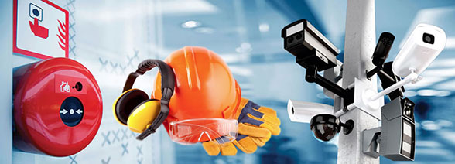

1. APPENDIX:

SOURCE CODE

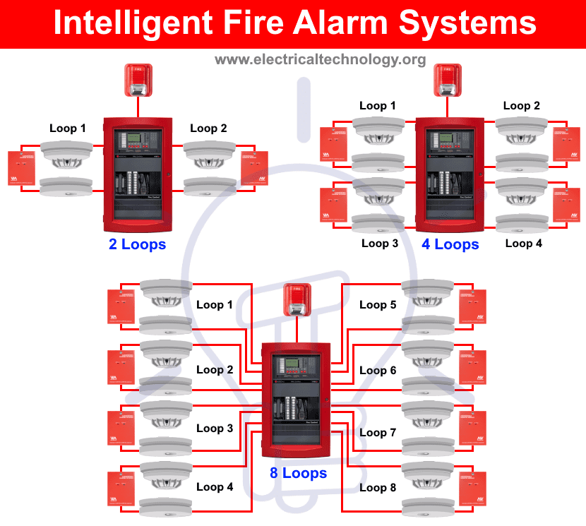

TYPES OF FIRE ALARMS

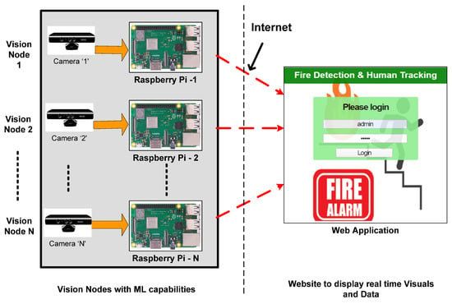

FIRE SAFETY MANAGEMENT USING RASPBERRY PI